# Programming Fundamentals and Unit Testing Regular Exam – 2 March 2025

Submit your zip file here: <https://judge.softuni.org/Contests/5375/Programming-Fundamentals-and-Unit-Testing-Regular-Exam-2-March-2025>

# 3. Unit Test Method: Even Numbers in Range

Test a given method which takes in **two integers** and returns all even numbers in the range.

## Examples

|  |  |
| --- | --- |
| **Input** | **Output** |
| 10 1 | Start number should not be greater than end number. |
| 23 23 | *(empty string)* |
| 21 23 | 22 |
| 1 5 | 2 4 |
| 0 0 | *0* |

The method is found in the **EvenNumbersFinder**.cs file:

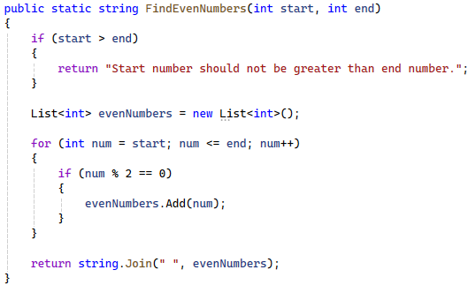

You are given a **test** **file** **EvenNumbersFinderTests**.cs containing **5 empty tests**. Implement all the unit tests:

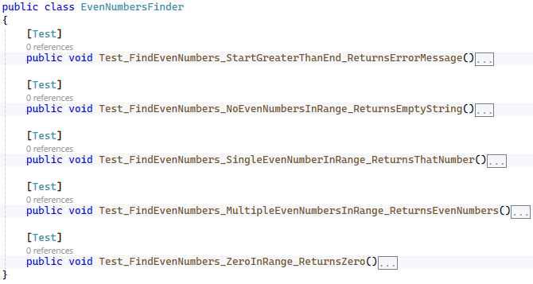

When you are ready make sure your **tests run:**

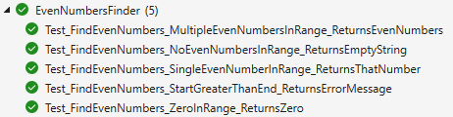

**IMPORTANT:** **DO NOT REMOVE OR CHANGE ANY NAMESPACES AND USINGS.**